

**VIRGINIA COMMONWEALTH UNIVERSITY**

**Statistical analysis and modelling (SCMA 632)**

**A1b: Analysis of IPL DATA of player performance**

**Rohan Arpit Dungdung**

**V01106712**

**Date of Submission: 18-06-2024**

**Player’s performance report in IPL**

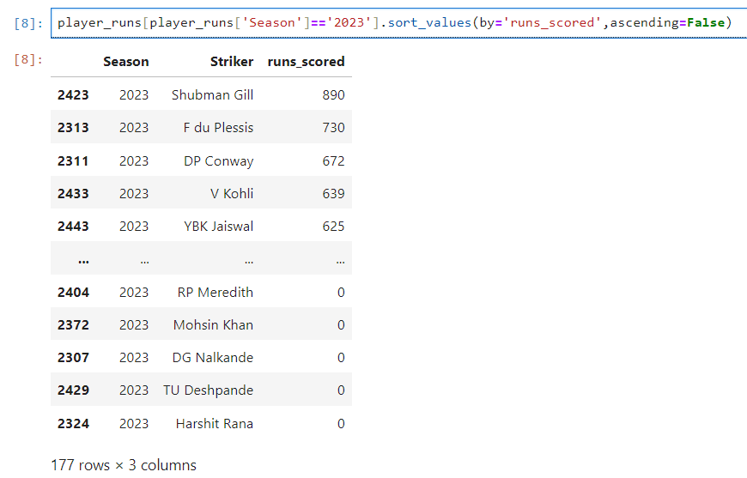

The table contains data for multiple cricket players, including the season they played in, their name, and the number of runs they scored. This is the list of players in the 2023 season and then sorting them by the number of runs scored in descending order.

The first line: player_runs [player_runs['Season']=='2023'], filters the table player_runs to only include players from the 2023 season.

The second line, .sort_values (by='runs_scored', ascending=False), sorts the filtered data by the number of runs scored in descending order.

The resulting table shows the top eight players in the 2023 season, ranked by the number of runs scored. Shubman Gill leads the list with 890 runs, while RP Meredith, Mohsin Khan, DG Nalkande, and TU Deshpande all scored zero runs.

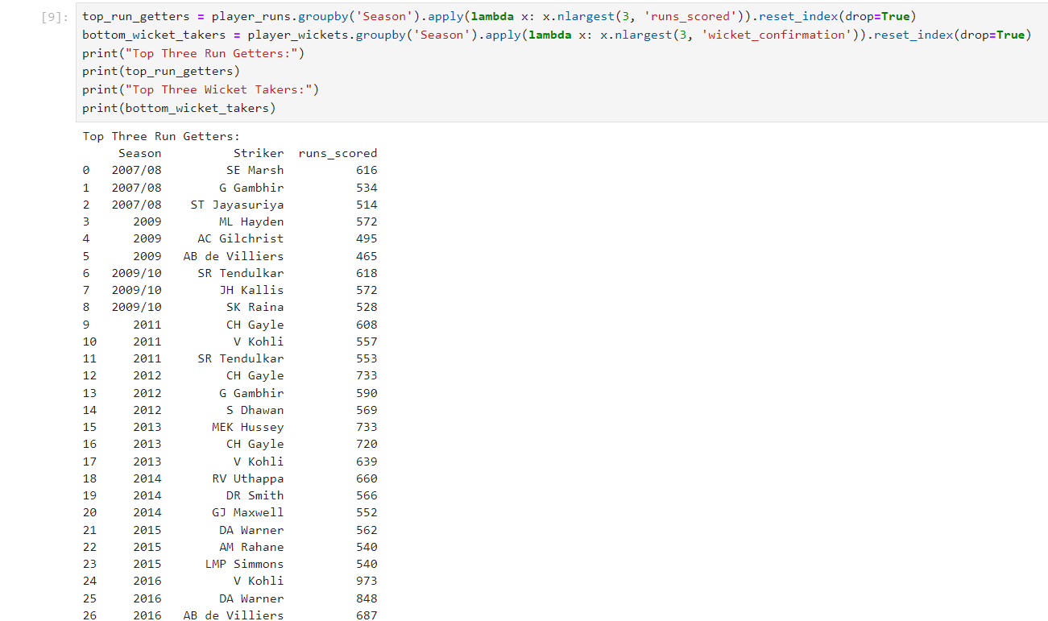

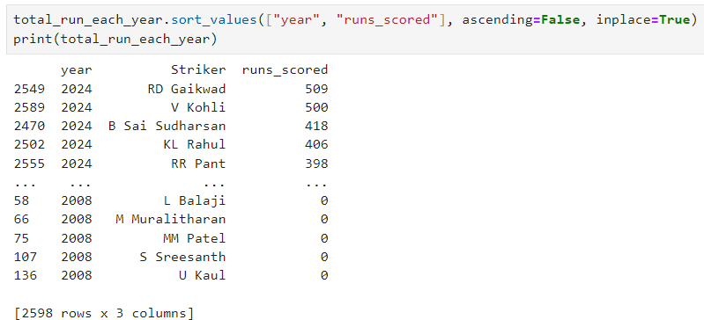The above data contains information about the top 3 run scorer each year and the bottom three run scorer of each year.

The above data contains information about the hightest run scored of 2024 and the lowest run scorer of 2008. For instance, the player RD Gaikwad scored the highest number of runs (509) in the year 2024, while MM Patel, S Sreesanth, U Kaul did not score any runs in the year 2008.

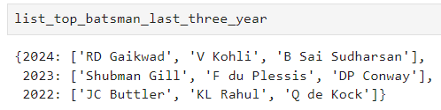

The above data contains the list of top 3 batsmen over the last three years.

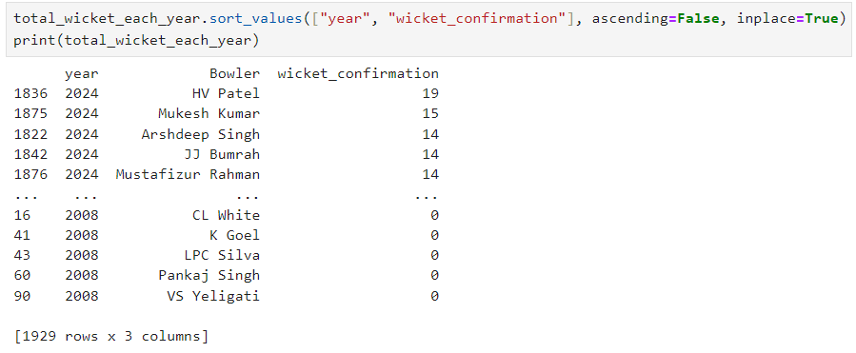

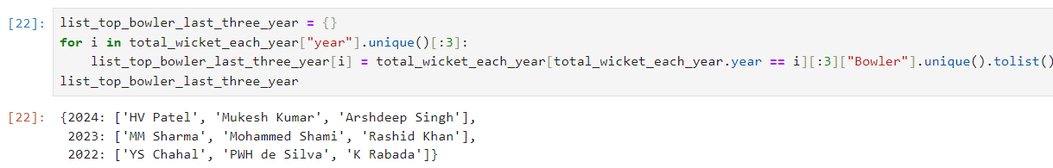The above data contains the list of highest wicket taker to lowest wicket taker

The above data contain highest wicket taker over the years 2024,2023,2022.

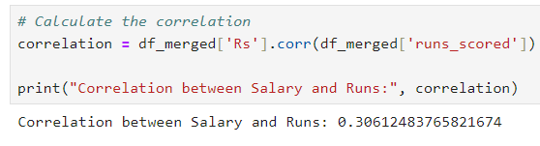A positive correlation coefficient indicates a positive relationship, where higher salaries are associated with higher runs scored. A negative correlation coefficient indicates a negative relationship, where higher salaries are associated with lower runs scored. A correlation coefficient of 0 indicates no linear relationship between the two variables.